**ASSIGNMENT 1**

**1. Explain the key features of Python that make it a popular choice for programming.**

The reasons why Python is a popular programming language are several. The following are some of the main characteristics that make it so popular:

* Readability and Simplicity: Python is an easy language to understand and write because of its simple, unambiguous grammar. Both novice and seasoned programmers may understand and maintain code more easily thanks to its readability.
* Versatility: There are many uses for Python, such as data analysis, scientific computing, web development, automation, and artificial intelligence. Its large standard library and the abundance of third-party libraries it offers contribute to its versatility.
* Ease of Learning: Python is a great option for novices because its syntax closely mimics that of natural language. Because of the language's simplicity, even non-programmers may understand programming concepts without being hindered by its syntax.
* Huge Community and Ecosystem: There is a sizable and vibrant Python development community. This indicates that a plethora of information, guides, and third-party libraries are accessible. Additionally, the community adds to a strong ecosystem of frameworks and tools that increase Python's functionality.
* Python is an interpreted language, meaning that commands are carried out line by line. This feature facilitates interactive programming and makes debugging easier.
* Python has dynamic typing, which eliminates the requirement for you to declare a variable's type at the time of declaration. This can speed up and increase the flexibility of coding, but it may also call for cautious management to prevent type-related problems.
* Cross-Platform Compatibility: Python is compatible with multiple operating systems, such as Windows, macOS, and Linux, making it cross-platform. This makes it possible to create applications that work well in a variety of settings.
* Wide-ranging Libraries and Frameworks: Python has an abundance of libraries and frameworks that make programming easier across a range of industries. Examples include NumPy and pandas for data analysis, TensorFlow and PyTorch for machine learning, and Django and Flask for web development.
* Support for Object-Oriented and Functional Programming: Python is compatible with a number of programming paradigms, including functional and object-oriented programming (OOP). Because of this versatility, developers can choose the optimal strategy for their particular requirements.
* .Integration Skills: Python has good interoperability with various technologies and languages. It can be used, for instance, to interface with databases, online services, and other systems, or to script programs written in other languages.  
    
  Together, these characteristics make Python a strong and approachable language that can be used for a variety of programming tasks and is appealing to a wide range of users.

**2. Describe the role of predefined keywords in Python and provide examples of how they are used in a programming.**

In Python, predefined keywords play a crucial role in defining the syntax and structure of the language. These keywords are reserved words that have special meanings and cannot be used as identifiers (e.g., variable names, function names). They are essential for the language's control flow, data structures, and other fundamental features. Here’s an overview of their roles:

* **Control Flow**: Keywords like if, elif, and else are used for conditional execution of code. Keywords such as for and while are used for looping, and break, continue, and return control the flow within loops and functions.
* **Function Definition**: Keywords like def are used to define functions, while lambda is used to create anonymous functions. The yield keyword is used in generator functions to produce a sequence of values.
* **Exception Handling**: Keywords such as try, except, finally, and raise are used to handle exceptions and manage errors.
* **Classes and Objects**: Keywords like class define new classes, while self refers to the instance of the class. The super keyword is used to call methods from a parent class.
* **Data Structures**: Keywords like list, tuple, and dict are not actual keywords but built-in types used to create and manipulate data structures. For instance, isinstance checks the type of an object.
* **Importing Modules**: Keywords like import and from are used to bring in modules and specific attributes from modules into the current namespace.
* **Variable Scope**: Keywords such as global and nonlocal are used to declare variable scope in nested functions.
* **Boolean Logic**: Keywords like True and False are Boolean values used in logical expressions.
* **Other**: Keywords like pass are used as placeholders where code is syntactically required but where no action is desired.

**3. Compare and contrast mutable and immutable objects in Python with examples.**

In Python, objects are categorized into mutable and immutable types based on whether their values can be changed after they are created. Understanding the differences between these two types is important for effective programming. Here’s a comparison along with examples:

**Mutable Objects:** Mutable objects are those whose state or value can be modified after they are created. This means you can change their contents without changing their identity (memory address).

Examples: Lists, Dictionaries, Sets

Characteristics:

Modifiability: You can change elements, add or remove items.

Behavior in Functions: Passing a mutable object to a function can affect the original object.

**Immutable Object**: Immutable objects are those whose state or value cannot be changed once they are created. Any modification results in the creation of a new object.

Examples: Integers, Floats, Strings, Tuples

Characteristics:

Immutability: The value cannot be changed after creation. Operations that modify an immutable object return a new object.

Behavior in Functions: Passing an immutable object to a function does not affect the original object.

**Comparison and Contrast**

1. Mutability:
   * Mutable: Can be changed in place (e.g., lists, dictionaries).
   * Immutable: Cannot be changed in place (e.g., strings, tuples).
2. Memory Allocation:
   * Mutable: Modifications are done in the same memory location.
   * Immutable: Modifications create new objects in new memory locations.
3. Performance:
   * Mutable: Can be more efficient for frequent changes since the same object is modified.
   * Immutable: Operations that modify the object result in new object creation, which can be less efficient but can improve safety and predictability in multi-threaded environments.
4. Function Behavior:
   * Mutable: Changes to the object inside a function reflect outside the function.
   * Immutable: Changes to the object inside a function do not affect the original object outside the function.

Understanding these characteristics helps in choosing the right type for your specific needs and in predicting how objects will behave when passed to functions or manipulated in your programs.

**4. Discuss the different types of operators in Python and provide examples of how they are used.**

In Python, operators are special symbols that perform operations on values or variables. They can be categorized into several types based on their functionality:

1. Arithmetic Operators: Used for mathematical operations.
   * + (Addition): Adds two values. Example: 5 + 3 results in 8.
   * - (Subtraction): Subtracts one value from another. Example: 10 - 4 results in 6.
   * * (Multiplication): Multiplies two values. Example: 7 * 2 results in 14.
   * / (Division): Divides one value by another, returning a float. Example: 8 / 4 results in 2.0.
   * // (Floor Division): Divides one value by another and rounds down to the nearest integer. Example: 7 // 3 results in 2.
   * % (Modulus): Returns the remainder of a division. Example: 10 % 3 results in 1.
   * ** (Exponentiation): Raises one value to the power of another. Example: 2 ** 3 results in 8.
2. Comparison Operators: Used to compare two values.
   * == (Equal to): Checks if two values are equal. Example: 5 == 5 results in True.
   * != (Not equal to): Checks if two values are not equal. Example: 5 != 3 results in True.
   * > (Greater than): Checks if one value is greater than another. Example: 7 > 3 results in True.
   * < (Less than): Checks if one value is less than another. Example: 4 < 6 results in True.
   * >= (Greater than or equal to): Checks if one value is greater than or equal to another. Example: 5 >= 5 results in True.
   * <= (Less than or equal to): Checks if one value is less than or equal to another. Example: 4 <= 5 results in True.
3. Logical Operators: Used to combine or invert boolean expressions.
   * and: Returns True if both expressions are true. Example: (5 > 3) and (2 < 4) results in True.
   * or: Returns True if at least one expression is true. Example: (5 > 3) or (2 > 4) results in True.
   * not: Inverts the boolean value. Example: not (5 > 3) results in False.
4. Assignment Operators: Used to assign values to variables.
   * =: Assigns a value to a variable. Example: x = 10 assigns 10 to x.
   * +=: Adds a value to a variable and assigns the result to that variable. Example: x += 5 is equivalent to x = x + 5.
   * -=: Subtracts a value from a variable and assigns the result. Example: x -= 3 is equivalent to x = x - 3.
   * *=: Multiplies a variable by a value and assigns the result. Example: x *= 2 is equivalent to x = x * 2.
   * /=: Divides a variable by a value and assigns the result. Example: x /= 4 is equivalent to x = x / 4.
   * //=: Performs floor division on a variable and assigns the result. Example: x //= 3 is equivalent to x = x // 3.
   * %=: Takes the modulus of a variable with a value and assigns the result. Example: x %= 7 is equivalent to x = x % 7.
   * **=: Raises a variable to the power of a value and assigns the result. Example: x **= 2 is equivalent to x = x ** 2.
5. Bitwise Operators: Operate on the binary representations of integers.
   * & (Bitwise AND): Performs a binary AND operation. Example: 5 & 3 results in 1.
   * | (Bitwise OR): Performs a binary OR operation. Example: 5 | 3 results in 7.
   * ^ (Bitwise XOR): Performs a binary XOR operation. Example: 5 ^ 3 results in 6.
   * ~ (Bitwise NOT): Inverts the bits of a number. Example: ~5 results in -6.
   * << (Left Shift): Shifts bits to the left. Example: 5 << 1 results in 10.
   * >> (Right Shift): Shifts bits to the right. Example: 5 >> 1 results in 2.
6. Identity Operators: Check if two variables refer to the same object.
   * is: Returns True if two variables point to the same object. Example: a is b checks if a and b are the same object.
   * is not: Returns True if two variables point to different objects. Example: a is not b checks if a and b are different objects.
7. Membership Operators: Check if a value is present in a sequence.
   * in: Returns True if a value is found in a sequence. Example: 'a' in 'apple' results in True.
   * not in: Returns True if a value is not found in a sequence. Example: 'b' not in 'apple' results in True.
8. Conditional Expressions: Used for inline conditional logic.
   * a if condition else b: Evaluates to a if the condition is True, otherwise evaluates to b. Example: x = 10 if y > 5 else 20 assigns 10 to x if y is greater than 5, otherwise assigns 20.

These operators allow for a wide range of operations in Python, making the language both versatile and powerful for various types of programming tasks.

**5. Explain the concept of type casting in Python with examples.**

Type casting in Python is the process of converting a value from one data type to another. Python is dynamically typed, meaning that variables don't have fixed types; their types are determined at runtime. Sometimes, you need to convert a variable's type to perform specific operations or ensure compatibility with other values or functions.

**6. How do conditional statements work in python? Illustrate with examples.**

Conditional statements in Python allow you to execute certain blocks of code based on whether a condition is True or False. They help you make decisions in your code and control the flow of execution. The primary conditional statements in Python are if, elif, and else.

1. If statement

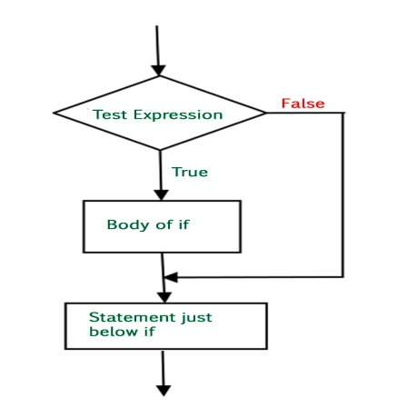

1. else statement

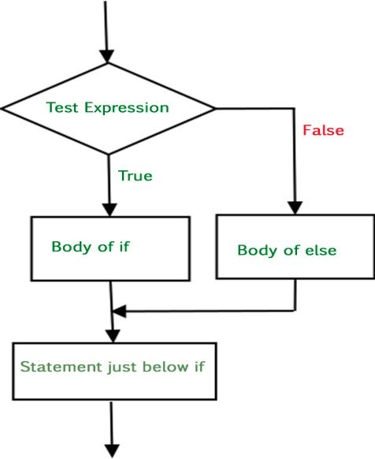

1. if-elseif statement

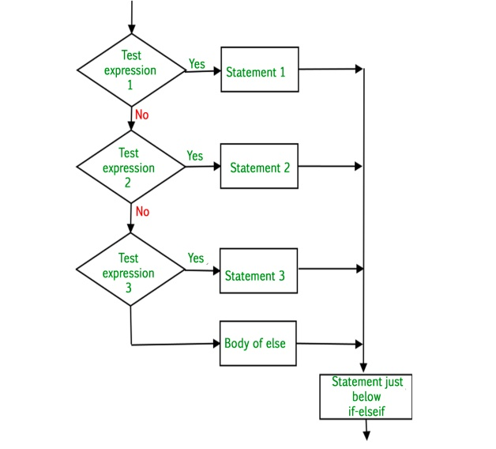

1. nested if statement

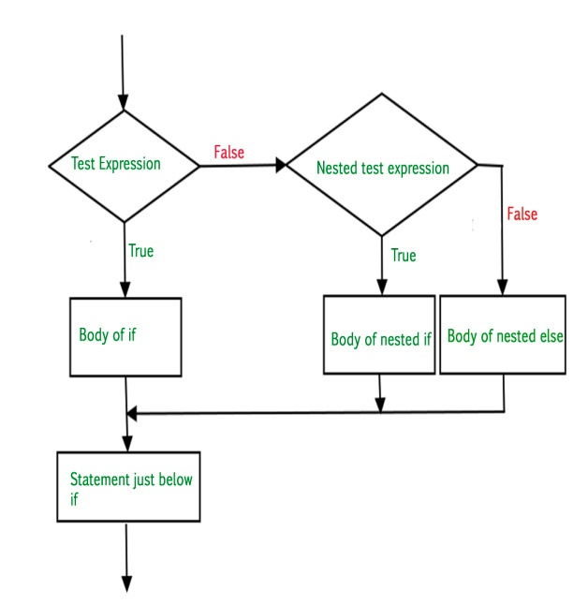

**7. Describe the different types of loops in python and their use cases with example.**

In Python, loops are used to repeatedly execute a block of code as long as a certain condition is met. Python provides two main types of loops: for loops and while loops.

1. For loop:

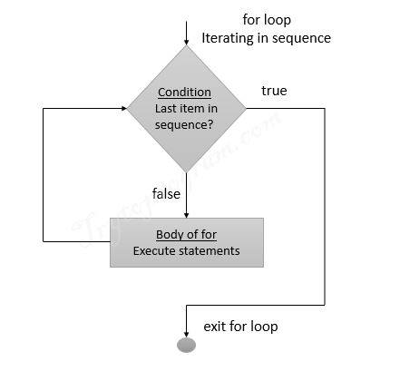

1. While loop

